Saul

Saul

Why do you persecute me?
Saul asked, ‘Who are you, Lord?’ The reply came, ‘I am Jesus, whom you are persecuting. But get up and enter the city, and you will be told what you are to do.’ The men who were travelling with him stood speechless because they heard the voice but saw no one. Saul got up from the ground, and though his eyes were open, he could see nothing; so they led him by the hand and brought him into Damascus. For three days he was without sight, and neither ate nor drank.
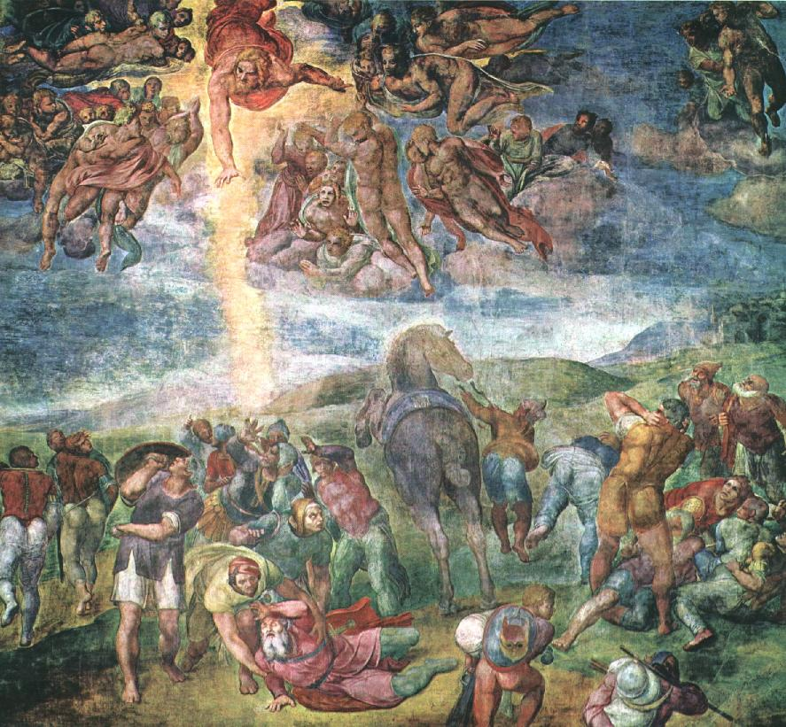

Spend time:

- Remembering that you are in the presence of God

- Think back over the past few weeks – have there been times when God was close? Times when God was distant?

- Saul made a huge change to his life – are there any changes, large or small you want to make to bring you closer to God.
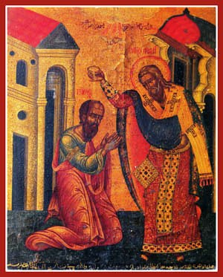
The Lord said to Ananias in a vision, ‘Ananias.’ He answered, ‘Here I am, Lord.’ The Lord said to him, ‘Get up and go to the street called Straight, and at the house of Judas look for a man of Tarsus named Saul. At this moment he is praying, and he has seen in a vision a man named Ananias come in and lay his hands on him so that he might regain his sight.’ But Ananias answered, ‘Lord, I have heard from many about this man, how much evil he has done to your saints in Jerusalem; and here he has authority from the chief priests to bind all who invoke your name.’ But the Lord said to him, ‘Go, for he is an instrument whom I have chosen to bring my name before Gentiles and kings and before the people of Israel; I myself will show him how much he must suffer for the sake of my name.’ So Ananias went and entered the house. He laid his hands on Saul and said, ‘Brother Saul, the Lord Jesus, who appeared to you on your way here, has sent me so that you may regain your sight and be filled with the Holy Spirit.’

- Who has helped you in your life?

- Write down their name on a piece of paper and place it in the basket as a prayer for them.
And immediately something like scales fell from Saul’s eyes, and his sight was restored. Then he got up and was baptized, and after taking some food, he regained his strength.


- Light a tea light and talk to Jesus about the week ahead- the things to be done, the things to be changed.

- Say the Lord’s Prayer

